**MCQ:**

1. main()  
   {  
   char *p1=”Name”;  
   char *p2;  
   p2=(char *)malloc(20);  
   while(*p2++=*p1++);  
   printf(“%sn”,p2);  
   }  
   what is the output?

# Which of the following statements is incorrect

# a. typedef struct new{ int n1; char n2; } DATA;

# b.typedef struct { int n3; char *n4; }ICE;

# c.typedef union { int n5; float n6; } UDT;

# d.#typedef union { int n7; float n8; } TUDAT;

1. Find the output of the following program main() { int x=5, *p; p=&x; printf(“%d”,++*p); }
2. consider the following C code  
   main()  
   {  
   int i=3,x;  
   while(i>0)  
   {  
   x=func(i);  
   i–;  
   }  
   int func(int n)  
   {  
   static sum=0;  
   sum=sum+n;  
   return(sum);  
   }  
   the final value of x is

# 5.The format specified for hexa decimal is a.%d b.%o c.%x d.%u

# Consider the following program sigment int n,sum=1; switch(n) { case 2:sum=sum+2; case 3:sum*=2; break; default:sum=0;} if n=2, what is the value of sum

# a.0

# b.6

# c.3

# d.none

1. # define prod(a,b)=a*b  
   main()  
   {  
   int x=2;  
   int y=3;  
   printf(“%d”,prod(x+2,y-10)); }

the output of the program is  
a.8  
b.6  
c.7  
d.none

1. Which of the following go out of the loopo if expn 2  
   becoming false  
   a.while(expn 1){…if(expn 2)continue;}  
   b.while(!expn 1){if(expn 2)continue;…}  
   c.do{..if(expn 1)continue;..}while(expn 2);  
   d.while(!expn 2){if(expn 1)continue;..}
2. How many times does the loop iterated ?  
   for (i=0;i=10;i+=2)  
   printf(“Hin”);

# Struct(s) { int a; long b; } Union (u) {int a; long b; } Print sizeof(s)and sizeof(u) if sizeof(int)=4 and sizeof(long)=4

1. What will be the result of the following program?  
   main()  
   {  
   char p[]=”String”;  
   int x=0;

if(p==”String”)  
{  
printf(“Pass 1”);  
if(p[sizeof(p)-2]==’g’)  
printf(“Pass 2”);  
else  
printf(“Fail 2”);  
}  
else  
{  
printf(“Fail 1”);  
if(p[sizeof(p)-2]==’g’)  
printf(“Pass 2”);  
else  
printf(“Fail 2”);  
}  
}

a) Pass 1, Pass 2  
b) Fail 1, Fail 2  
c) Pass 1, Fail 2  
d) Fail 1, Pass 2  
e) syntax error during compilation

1. f(char *p)  
   {  
   p=(char *)malloc(sizeof(6));  
   strcpy(p,”HELLO”);  
   }  
   main()  
   {  
   char *p=”BYE”;  
   f(p)  
   printf(“%s”,p);  
   }  
   what is the output?

Ans: BYE

1. Which of the following is not an infinite loop ?  
   a.while(1){  
   ….  
   }  
   b.for(;;){  
   …  
   }  
   c.x=0;  
   do{  
   /*x unaltered within theloop*/  
   …  
   }while(x==0);  
   d.# define TRUE 0  
   …  
   while(TRUE){  
   ….  
   }

Ans: True here equals zero…which is false.  
so the correct answer is D.

# Write a C code to reverse a string using a recursive function, without swapping or using an extra memory.

Ans:

void reverse(char *str)  
{  
if(*str)  
{  
reverse(str+1);  
putchar(*str);  
}  
}

1. Unsigned char c;  
    for ( c=0;c!=256;c++2)  
    printf(“%d”,c);

No. of times the loop is executed ?

1. What will be the output if limit = 6?  
     
   Read limit  
   n1 = 0, n2= 1, n3=1, count = 1;  
   while count <= limit  
   count=count+1  
   print n3  
   n3 = n1 + n2  
   n1 = n2  
   n2 = n3  
   End While

a)112358

b)12358

c)123581321

d)12358132

17. What is the output of the following pseudocode for a=3, b=8, c=7 ?

Integer funn(integer a,integer b, integer c)

if ((a^8) < 8)

c=a+c

c=a+c

End If

Return a+b+c

a)18

b)12

c)23

d)29

18. What will be the space required for this piece of code?

int sum (int B[], int n)  
{  
 int s = 0, j;  
 for (j = 0; j < n; j++)  
 s = s + B[i];  
 return s;  
}// sizeof(int) = 2 bytes

a)2n+8

b)2n+4

c)2n

d)2n+2

19. What is the output of the following code?

Character *ptr

Set *ptr= ‘Pointers’

Print *&*&*ptr

a)Segmentation fault

b)P

c)Compiler error

d)Pointers

20. Which of the following permutations can be obtained in the output using a stack assuming that the input is in the sequence 1, 2, 3, 4, 5 in that order?

a) 3, 4, 5, 1, 2

b) 3, 4, 5, 2, 1

c)1, 5, 2, 3, 4

d)5, 4, 3, 1, 2

21. Evaluate the postfix expression:

12+3*42-31+*-

a) 3

b) 1

c) 0

d) 2

22. Which of the data structures can have more than one logical way of traversing ?

a) Arrays

b) Linked list

c) Queue

d) Tree

23. Which of the following is true concerning the directed graph shown below?

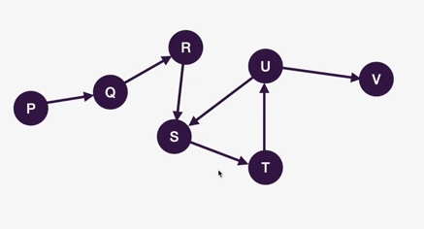

a)Only two topological orderings are possible

b)Only one topological ordering is possible

c)More than two topological orderings are possible

d) No topological ordering is possible

24. What will be the output of the following pseudocode for input a = 30, b = 60, C = 90?

Integer a, b, c, sum

Read a, b, c

Set sum = a + b + c

if ((sum EQUALS 180) and (a NOT EQUALS 0) and (b NOT EQUALS 0) and (c NOT EQUALS 0))

Print " Success"

Otherwise

Print "Fail"

End if

a)Success b)Fail

c)Compilation error d)None of the above

25. What will be the output?

#include <iostream>

using namespace std;

int main()

{

int a = 32, *ptr = &a;

char ch = 'A', &cho = ch;

cho += a; *ptr += ch;

cout << a << ", " << ch << endl;

return 0;

}

a)129,a b)32,A c)129,A d)32,a

26. Find the missing value in the grid.

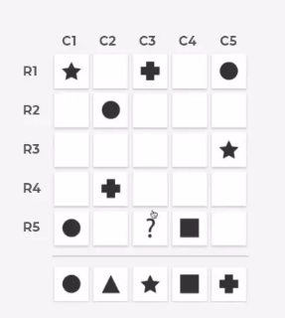

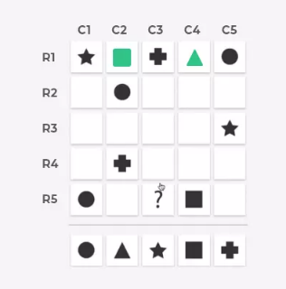

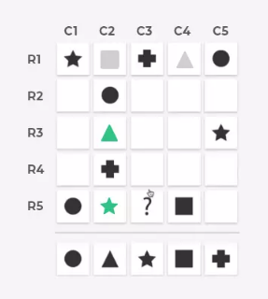

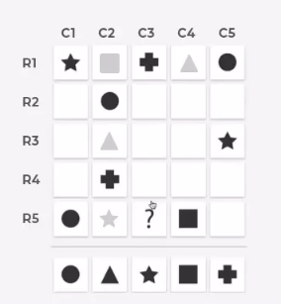

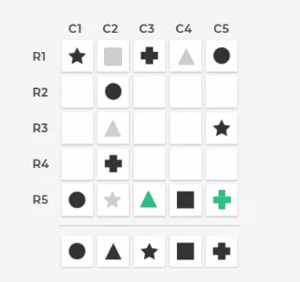

27. The below two grid follows a rule. Find the set of grid

that follows the rule.

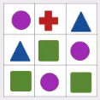

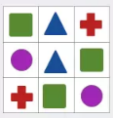

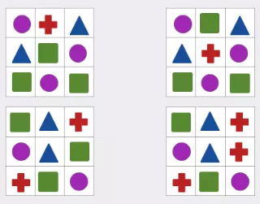

28. Put the red ball into the hole in minimum number of steps

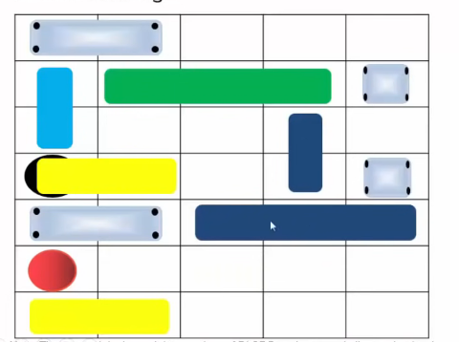

Answer:

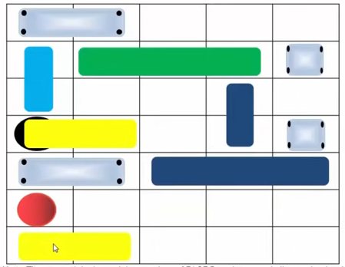

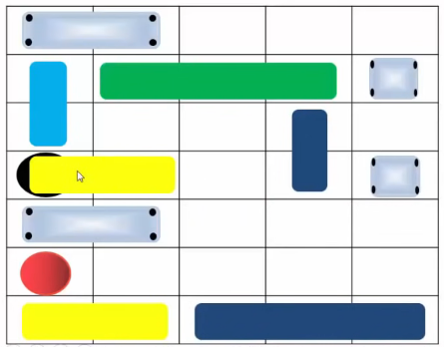

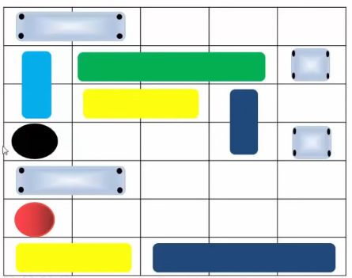

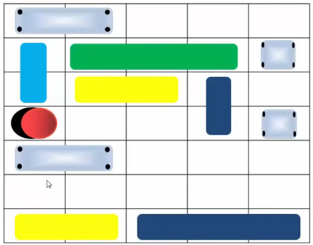

**Normal Programming**

1. Get a 3-digit or 2-digit no and find reverse the given no and add it with the same no. Check whether it is a palindrome. If it is a palindrome, terminate the process or else take the sum as the input and repeat the same process until a palindrome is obtained. And terminate the program if the palindrome is not obtained in 5 steps.

Eg: Input:27

27+72=99

Output : It is a palindrome

1. Assume ‘n’ taxi’s available and distance between two consecutive point is 15km. A linear path

A B C D E F is available and time taken to travel between adjacent point is 1hr. Initially all taxi’s are at point A. The customer gives pickup tie, pickup position , destination position and tax company gives taxi number allocated , reaching time.

Cost : for 1st 5km : Rs. 500 and for subsequent kms : Rs. 10

Write a program to (a) find travel history of each taxi car (b) If more than one taxi are available then one who earned less is allotted (c) If no taxi is available then print rejected.

1. Given an integer n, form a number triangle.

Example : if n = 5,

output:

0

5 0 5

4 5 0 5 4

3 4 5 0 5 4 3

2 3 4 5 0 5 4 3 2

1. 2 3 4 5 0 5 4 3 2 1
2. Find the maximum & minimum of two numbers in a single line without using any condition & loop.
3. Write a program to check for equality of two numbers without using arithmetic or comparison operator
4. Write a program to print 100 times “Hello” without using loop & goto statement
5. The square arrangement of whole numbers

1 2 3 4

2 3 4 1

3 4 1 2

4 1 2 3

is called a 4 x 4 LATIN SQUARE.

because each whole numbers 1 ,2 , 3 , and 4 appear once and only once in each

row and column. There are many ways to arrange the numbers and still make a

LATIN SQUARE.

Of all the 4 x 4 LATIN SQUARES, the one above has a simple pattern. We call it a

SIMPLE 4X4 LATIN SQUARE.

Write a program that will generate a similar SIMPLE N x N LATIN SQUARE for any

whole number N between 2 and 9.

Test your program with N = 6 and N = 9.

Sample Run

ENTER A WHOLE NUMBER BETWEEN 2 AND 9: 6

SIMPLE 6X6 LATIN SQUARE

1 2 3 4 5 6

2 3 4 5 6 1

3 4 5 6 1 2

4 5 6 1 2 3

5 6 1 2 3 4

6 1 2 3 4 5

1. Get a 3 digit or 2 digit number and add it with the reversed number. Check whether the sum is palindrome if not add it with the reversed number and check whether it is palindrome.

Example:

39+93=132

132+231=363 Stop

122+221=343 Stop

173+371=544

544+445=989 Stop

If the iteration reaches five (5) terminate the program

1. Taxi booking system based on following conditions

The program should work for ‘n’ number of taxis.

1. First of all the taxis are in the same position
2. There are 6 points A,B,C,D,E and F which are in straight line
3. The distance between each and every point is 15 km.the amount to be paid for the taxi should be based on,
4. For the 1st 5km ---Rs.500, Next---Rs.10 for each km
5. Get the starting point, destination, point, pickup time and customer ID from the user
6. Taxi should allotted to customer based on,
7. Nearest starting point
8. Taxi with lowest salary
9. Pickup time
10. Write a program to print all permutations of a given string. Note here you need to take all combinations as well, say for the input ABC the output should be as follows:

**Input:** ABC

**Output:**

A

B C

AB AC BA BC CA CB

ABC ACB BCA BAC CBA CAB

1. Find the strength of the given password string based on the conditions  
   Four rules were given based on the type and no. of characters in the string.  
   Weak – only Rule 1 is satisfied or Rule 1 is not satisfied  
   Medium – Two rules are satisfied  
   Good – Three rules satisfied  
   Strong – All Four rules satisfied

I/P: Qw!1        O/P: Weak  
I/P: Qwertyuiop      O/P: Medium  
I/P: QwertY123       O/P: Good  
I/P: Qwerty@123    O/P: Strong

1. Set columns and rows as zeroes

Problem Statement: Given a two-dimensional array, if any element within is zero, make its whole row and column zero. Consider the matrix below.

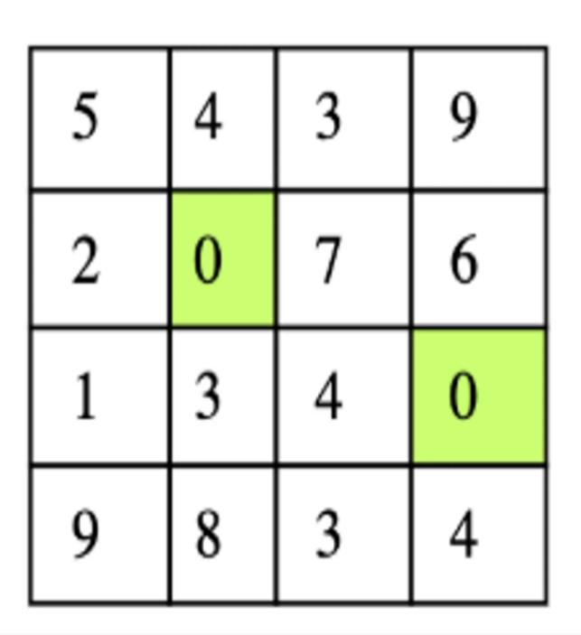

Given matrix

There are two zeros in the input matrix at positions (1,1) and (2,3). The output of this should be a matrix in which the first and second rows become zero and the first and third columns become zero. Below is the expected output matrix.

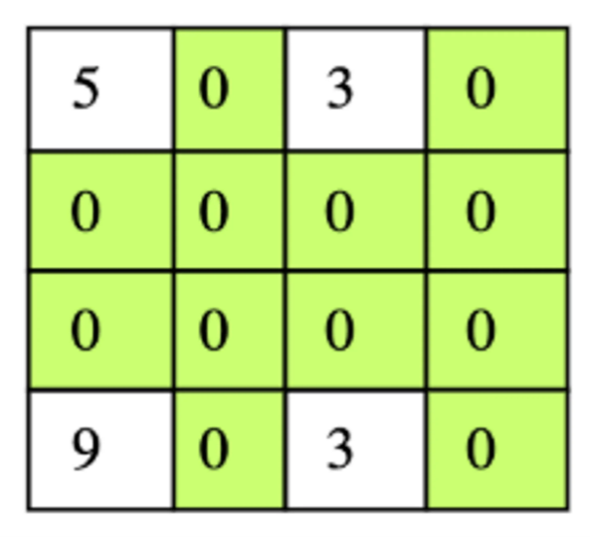

Expected output

1. Suppose there is a circle. There are N petrol pumps on that circle. You will be given two sets of data.  
   1. The amount of petrol that every petrol pump has.  
   2. Distance from that petrol pump to the next petrol pump.  
   Find a starting point where the truck can start to get through the complete circle without exhausting its petrol in between.  
   Note :  Assume for 1 litre petrol, the truck can go 1 unit of distance.

Example 1:

Input:

N = 4

Petrol = 4 6 7 4

Distance = 6 5 3 5

Output: 1

Explanation: There are 4 petrol pumps with

amount of petrol and distance to next

petrol pump value pairs as {4, 6}, {6, 5},

{7, 3} and {4, 5}. The first point from

where truck can make a circular tour is

2nd petrol pump. Output in this case is 1

(index of 2nd petrol pump).

Expected Time Complexity: O(N)  
Expected Auxiliary Space : O(1)

Constraints:  
2 ≤ N ≤ 10000  
1 ≤ petrol, distance ≤ 1000